**PA - 307.2.2 - Practice Assignment -**

**Create a Wireframe for your Login and Registration Page**

**Lab Objective:**

In this assignment, you will design two forms; one is for the login page, and the other one is for the registration page.

**Introduction**

A wireframe is a two-dimensional illustration of a page’s interface that specifically focuses on space allocation and prioritization of content, functionalities, and intended behaviors. For these reasons, wireframes typically do not include any styling, color, or graphics. Wireframes also help establish relationships between a website’s various templates.

Look at different websites for inspiration if necessary. You will create a login page for your capstone project. You can create two pages or one page for a user to register and login.

Easy to use drawing software available to use to create a wireframe includes:

* Google Drawing.
* Paint (Windows).

Examples:

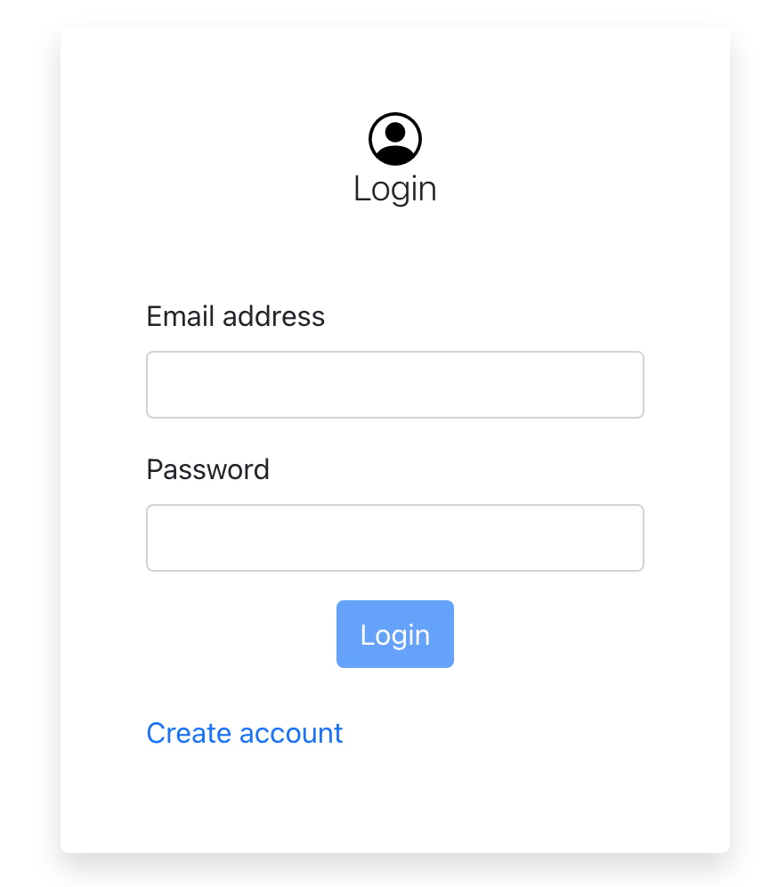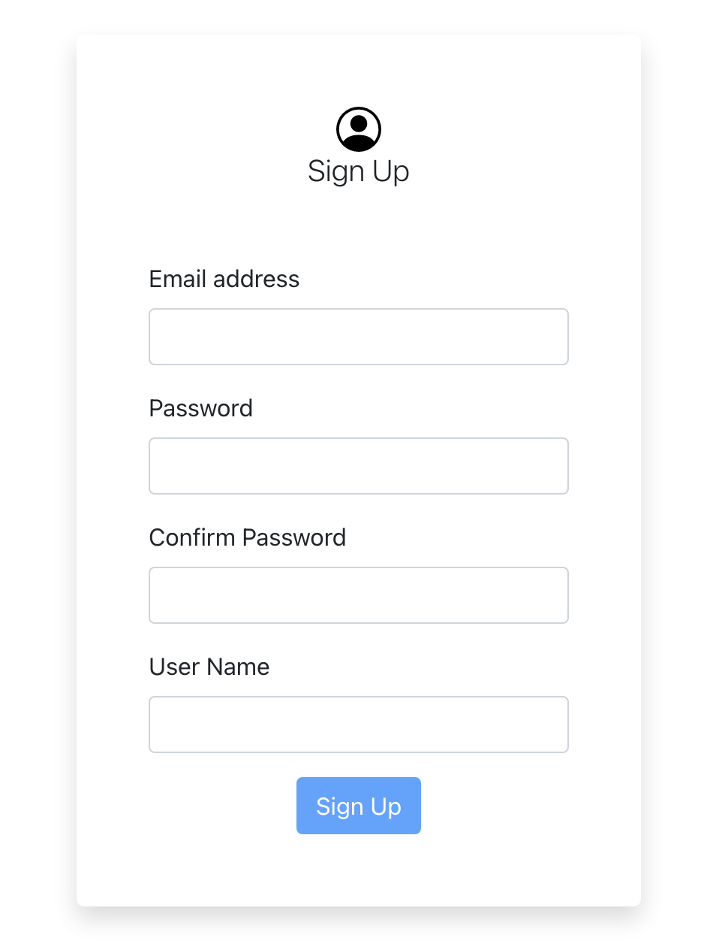

**Instructions:**

Create a Wireframe for Login page and Registration Page as shown above in the screenshot, and you can add more fields (options) in the form.

Reference for motivation: [12 Best Practices for Sign-Up and Login Page Design](https://uxplanet.org/12-best-practies-for-sign-up-and-login-page-design-69d6cd045cf)

**Submission Instructions:**

Include the following deliverables in your submission -

* + Submit your source code or screenshots using the Start Assignment button in the top right corner of the assignment page in Canvas.

| **Instructions for Canvas Assignment Creation** |
| --- |
| **Assignment Name: PA - 307.2.1 - Practice Assignment - Create a Wireframe for your Login and Registration Page**  **Points: 100**  **Assignment Group: Module 307 - Fundamentals of HTML/CSS (Not graded)**  **Display Grade As: Complete/Incomplete**  **Do not count this assignment towards the final grade: Checked**  **Submission Types: File Upload Everything else is the default.** |